**LAB 4: Automation Test and Test reporting**

**Students do the steps below:**

1. Read and understand the template of Template Defect Log (**Template_Defect_Log.xls**)
2. Create two file following the template: Unit Test Defect Log, System Test Defect Log.
3. Perform Automation test in Lab3.
4. Write the result in “Unit Test Case” file.
5. **Log the defect in “Unit Defect Log Report”**
6. **Perform black box test cases in Lab1.**
7. **Write the result in “System Test Case” file.**
8. **Log the defect in “System Defect Log Report”**

**Change logic code**

* **+Manual test: change logic of check month**

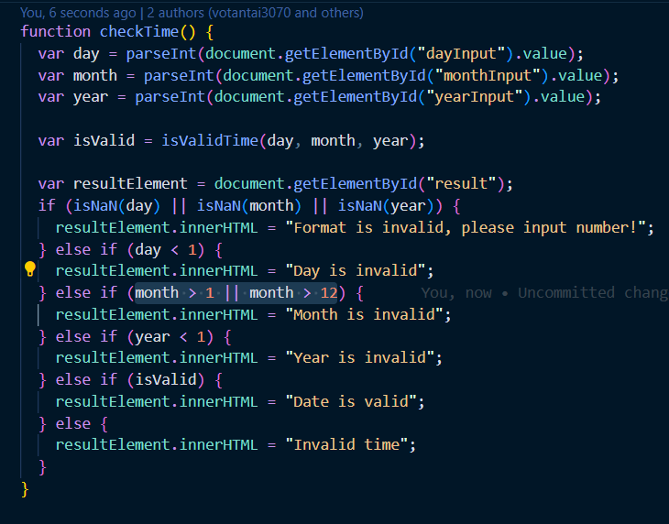

* **+Automation test:**

**Check date : No check logic valid day**

* **Check day in month: No check when day = 31**
* **A picture containing text, screenshot, software, multimedia software

  Description automatically generated**

**Run test lab 1**

**5/8 test case is fail**

**Run test lab 2**

**Checkdate: 5 failed, 5 passed, 10 total**

**Checkdayinmonth:** **6 failed, 4 passed, 10 total**